**MONK MODE FULL GUIDE**

**WRITE DOWN YOUR GOALS**

Think of what you want to do in life and start setting some goals for yourself. **Create a list**, you can even do a **short term** and **long term** list. **Write it down and put it somewhere you can see everyday**. This can be on your wall, your phone, etc. The reason for this is because it will serve as a reminder and it will work as an **affirmation**. This will then push you to work on them. Writing the goals down is the first step to taking action. This naturally means you are serious about it instead of just thinking about the goals in your head.



**CUT BAD HABITS, BUILD GOOD ONES**

Time to quit all the vices. **No more** **video games, junk food, partying, dating, drinking, smoking, etc**. It is okay to take a break and engage in some sort of entertaining activity, but it should be kept at a minimum. Its time to get dopamine from more productive activities.

Doing this will not be easy, and its ok to relapse. The first step is to decrease the frequency of the bad habits/activities. You won’t be able to just stop everything in 1 day. It is not realistic. However, **self talk is important and you must remind yourself of the big picture. Remember why you are starting all this**.

The **gym** is one of the first great habits to start with and a key stepping stone in self improvement. It is both recreational and productive at the same time. It is very tough at the beginning, but once you get used to it and start seeing the progress in your body, you will feel good mentally as well. Eat healthy and get plenty of sleep, don’t stay up late. These are some small steps to get started with building good habits and developing discipline/consistency.

**Time management** is the next important foundation to build. Learn to better manage your time by prioritizing tasks from most to least important and plan your schedule ahead of time. A good way to do this is to plan before the start of a new week. So on a weekend, decide the main tasks you need to do and plan out your entire week. Keep entertainment time low as your focus is to be productive on your goals.



**TAKE ACTION**

Time is of the essence, and you are running out of it. This is a great reminder to not wait too long to start something. Regrets will hurt more A great way to reset your mindset when it comes to taking action will be from 2 phrases that come from stoicism. **Memento Mori** and **Amor Fati**.

**MEMENTO MORI:** This phrase origins from the philosopher Friedrich Nietzsche and literally means “Remember you will die.” It is a phrase that I have used to remind myself that time cannot be wasted and I must put in the work in order to achieve the results I desire before it’s too late.

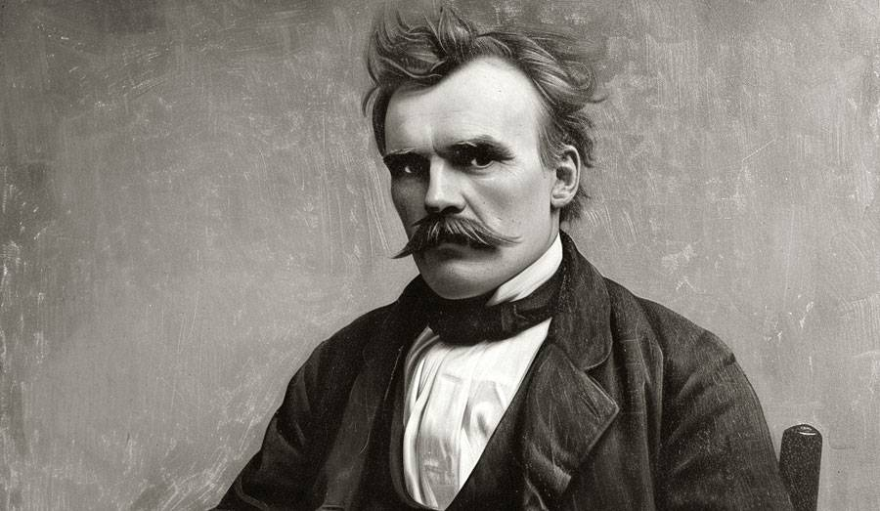

**AMOR FATI:** This phrase was brought to fruition by Socrates and it translates to “love of one’s fate.” It is used to describe an attitude in which one sees everything that happens in one's life, including suffering and loss, as good or, at the very least, necessary. If you are going through something in life, do not avoid it. Accept it and learn to overcome it. There is a reason why it is happening and you have to either see it as a good thing, or a necessary thing so that you can start doing something about it.

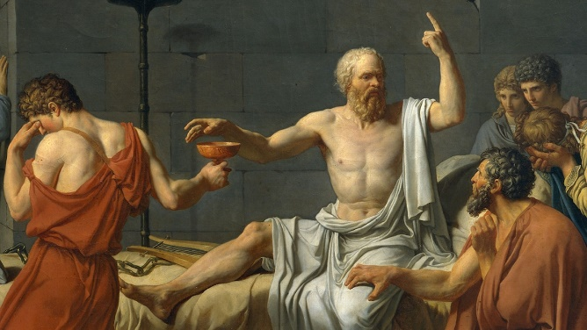

**STAY THE COURSE**

Monk mode can vary from people to people depending on their age and life situation. Ideally it is for individuals who have been severely slacking in completing tasks or getting their life in order. It requires serious focus and an extended period of time. An individual must go through at least **1 year of monk mode in their entire lifetime**. This is where all the major progress in personal development is made. This will build discipline, good habits, and the ability to set priorities and focus on what matters more. Certain times, some individuals may only need a couple months or weeks of monk mode. That is someone that has already made progress in life and is just needing a bit of time to get some stuff done. Either way, monk mode is a huge key to success and can be applied in various ways subject to the individual’s liking.

Remember, if you fail and indulge in vices/entertainment activities, its okay. It may happen as we are human and not robots. But that’s why reminding yourself of the phrases as mentioned above and looking at your goals everyday are important. It will set you back into the grind mindset. Constantly remind yourself why you started this journey, why its important and what the big picture is.

